Show Team Wear
- You must be an active rider with the show team to order show team wear. An active rider is one who attends at least one show a year and has leased a GES horse on an ongoing basis.
- All items are high quality with brand names (Hanes, Port Authority, Harrington and Jerzees). Color options are shown below. The GES logo is on the back of hoodies with Show Team & riders name on the front. Fleeces & Polo’s have a small logo on the front chest with Show Team & riders name opposite. Sweat pants & track pants say show team with jumping horse. Track pants are wind proof & weather resistaint but breathable.
- All itmes are embroidery except the pants which are screen printed.
- All items have pockets (less the polo’s).
- Items are available in Adult & Youth sizes. If you should need Young Rider sizes or toddle sizes please contact us.
- Show Team horse items are at the bottom of the page. Please let Robyn know if you need help with sizes.
- Horse items are embroidered as follows: Rain Sheet has rider initials or horses name on chest. Cooler, scrim & stable sheet have riders last name or horses show name on left side (middle of barrel). Baby pads have GES logo on left side, riders name/initials or a horse name can be added.

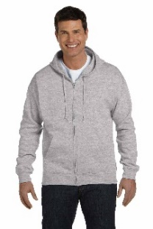
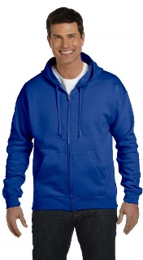
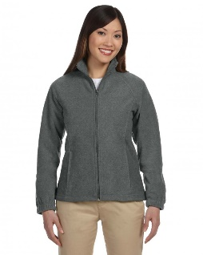
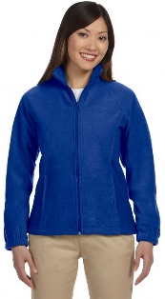
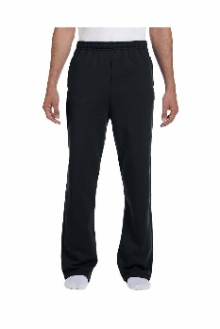
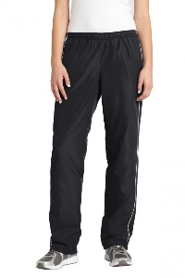
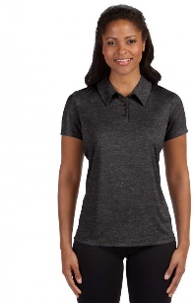
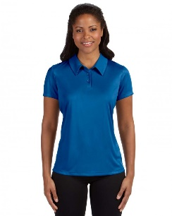
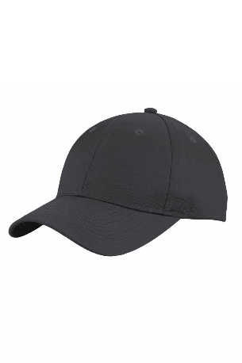
Hoodies - $65 Fleeces - $35 Sweats - $35 Track - $35 Polo’s- $35

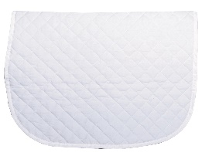
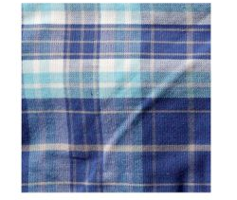
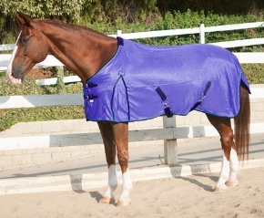
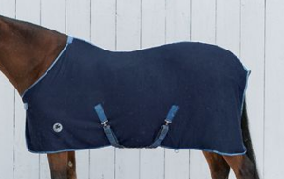
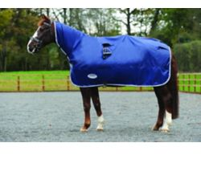
Cooler - $75 Rain Sheet - $75 Scrim - $95 Stable Sheet - $85 Baby Pads - $25

TO ORDER: Send an email with the following.
- Rider name as you want it spelled on item.
- The clothing size of the rider (number not S/M/L) please note if you would like the size exact or with extra room.
- How many of each item you would like.
- Specify color of item if applicable. If there is a name option (see horsewear) please specify what options you would like.
Next Order deadline is Oct. 1st.

