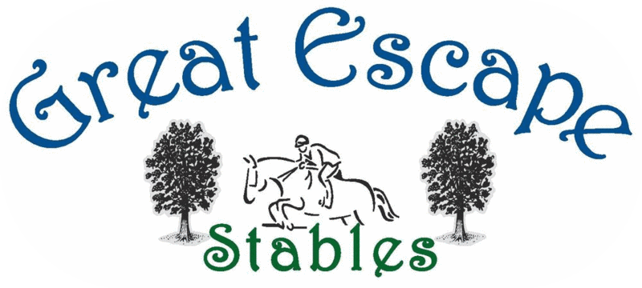
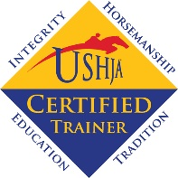
Lesson & Program Menu

Recreational Programs
The following programs are designed for the casual rider who is new to riding or seasoned riders working at the trot & canter levels (A-C) either English or Western. Program details are on our website.

Ages 3 to 6 - Pony Pals $125/month
Meets 3 times/month.
Classes focus on safety and hands-on activities with a short pony ride at the third class.

Ages 6 to Adult - 30 min. Private Lessons $195/month
Lesson includes grooming/tacking/basic mounted skills/untacking.
Riders Level B & above may arrive early to groom & tack to increase mounted time.
All riders will need to obtain paddock boots, helmet & grooming tote.
Riders in these lessons should also attend our horsemanship classes for additional grooming instruction.

Equine Therapy Time $25
Unmounted sessions involving grooming, grazing, bathing, in hand arena work.
Riders looking to spend time with horses on the ground and have had at least 8 lessons (at GES).

Practice Rides (Level B+ & C) $45

Half Lease (Levels B+ & C) $230/month
Riders must be taking a minimum of 4 lessons per month & be able to groom/tack on their own.
Riders must have their own saddle pads, grooming & bathing equipment.

Half Lease (Levels B+ & C) $500/month
Maybe done without also taking lessons but needs a trainer’s approval.
Riders must be able to groom/tack on their own.
Must have own saddle pads, grooming, bathing equipment & SHOULD have their own saddle.

Competitive Show Program
For riders new to riding, with little to no experience; and experienced riders already at the jumping level who would like to improve their jumping while also joining our show team.

30- 60 min. Intro. Lessons (Level A-C) $375/month (1 lesson/week)
All riders will need to obtain paddock boots, half chaps, helmet & grooming tote.
Level B+ & above includes 2 practice rides/month.

30 min. Private (Level B & above) $450/month (2 lessons/week)
Riders must at least arrive 30 mins. early to groom & tack.
Riders will need to obtain their own saddle, saddle pad & bathing items.

1-hour Group (Level B & above) $450/month (2 lessons/week)
Riders must at least arrive 30 mins. early to groom & tack.
Riders will need to obtain their own saddle, saddle pad & bathing items.

Practice Rides (Level B+ & C) $45

Half Lease (Level B+ & above) $750/month (3 rides/week)
Must have own saddle, saddle pads, grooming and bathing items.
2 lessons & 1 practice ride or 1 lesson & 2 practice rides.

