Current Barn Wear
- All barn wear items are high quality items with brand names (Hanes, Port Authority, Harrington and Jerzees). Our barn wear is black or charcoal/heather gray. The GES logo is on the back of hoodies & jackets with riders name on the front. Fleeces & Polo’s have a small logo on the front chest with the riders name opposite. Bennies & base ball hats have logo on the front with rider name on the back. Sweat pants to wear in the barn (covers breaches in winter to stay warmer or clean) have barn name with a jumping horse.
- All itmes are embroidery except the pants which are screen printed.
- All barn wear items have pockets (less the polo’s and hats). There are 3 barn jackets to choose from. The 1st one below is a puffer coat (warm, lightweight & water/wind resistaint), 2nd is nylon outside & fleece lined (warm, windproof & water resistaint), 3rd is an all weather 3 in 1 jacket, fleece lined (wind & water proof). All 3 have Adult sizes (xs to 3 XL), the 2nd one has Youth sizes.
- Barn wear items are available in Adult & Youth sizes. If you need Young Rider sizes or toddle sizes please contact us.
- Show team riders there is a separate page for Show Team Wear.
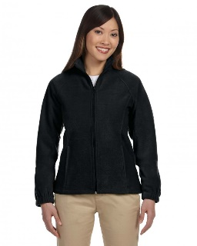
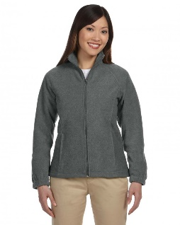
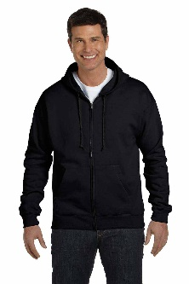
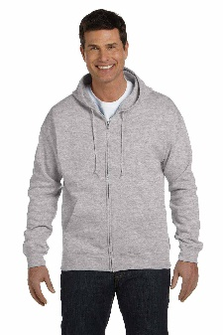
Hoodies - $65 Fleeces - $35
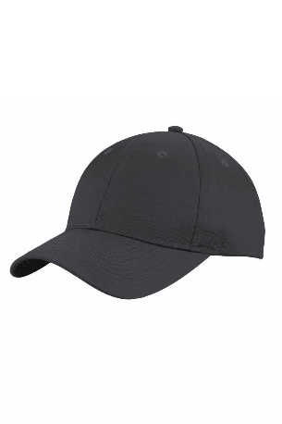

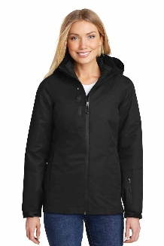
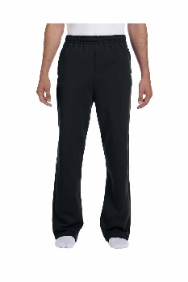
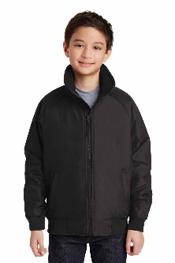
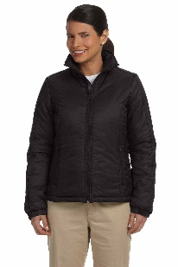
Jackets – 1st $60, 2nd $60 (Youth & Adult), 3rd $130 Sweats - $35

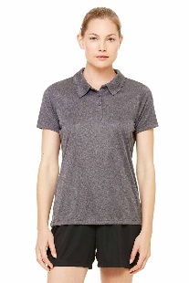
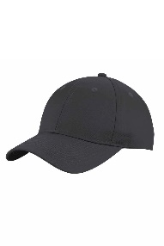
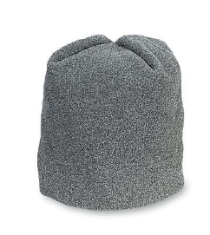
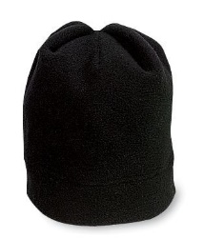
Beanie’s -$25 Baseball - $25 Polo’s - $35
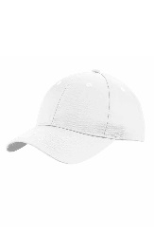

TO ORDER: Send an email with the following.
- Rider name as you want it spelled on item.
- The clothing size of the rider (number not S/M/L) please note if you would like the size exact or with extra room.
- How many of each item you would like.
- Specify color if applicable.
Next Order deadline is Oct. 1st.

